**Scratch Assay Analysis protocol – Team Lissa**

Developed by Lucas Dumoulin

# **Optional: Setting a Global Scale for the run**

* Use the straight-line selection tool [](https://serc.carleton.edu/details/images/19434.html) to drag out a line across the scale bar.

**TIP:** If you hold down the shift key while selecting with this tool, it forces your selection to be perfectly horizontal

* Select **Analyze > Set Scale...** The Set Scale window opens. The distance you measured in pixels will be displayed. Enter the Known Distance value and µm for the Unit of Length.

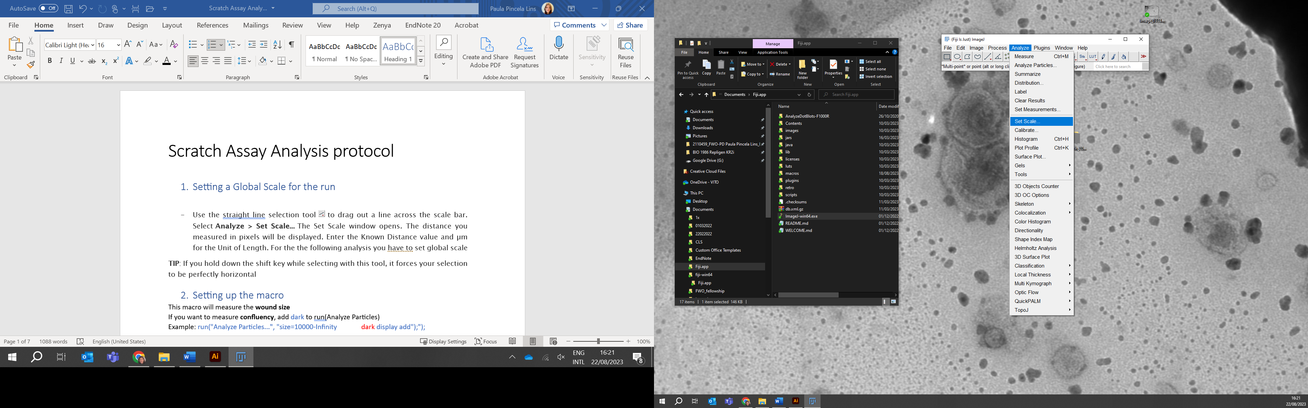

* The distance you measured in pixels will be displayed. Enter the Known Distance value and µm for the Unit of Length. For the following analysis, set global.

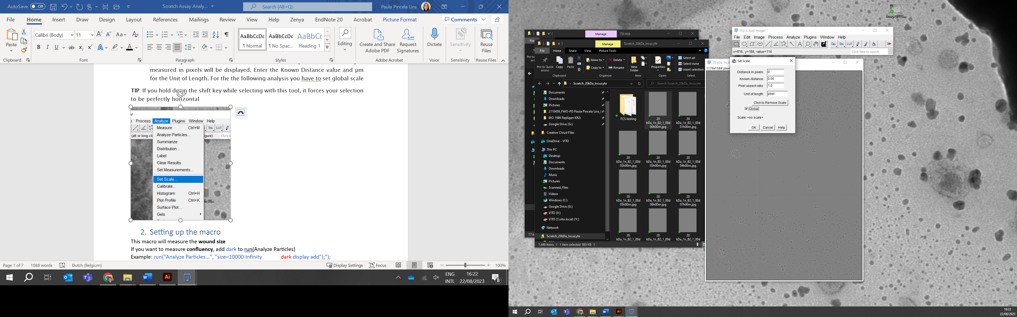

* For the following set of experiments in the Incucyte:

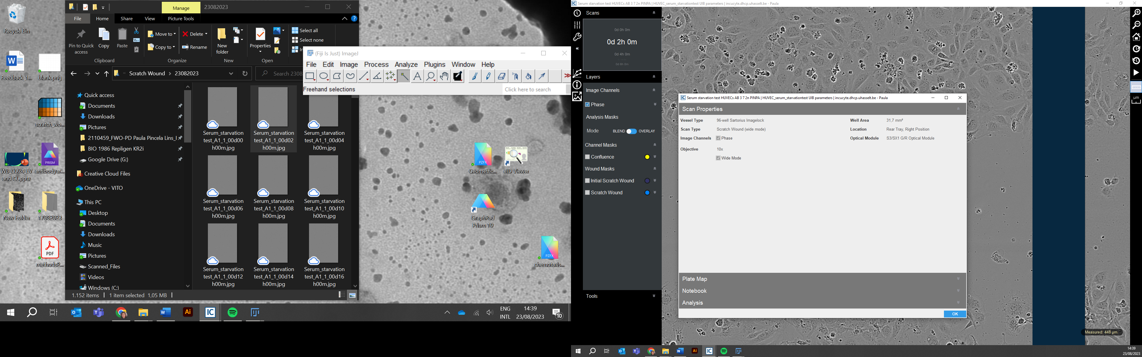

* Add these values

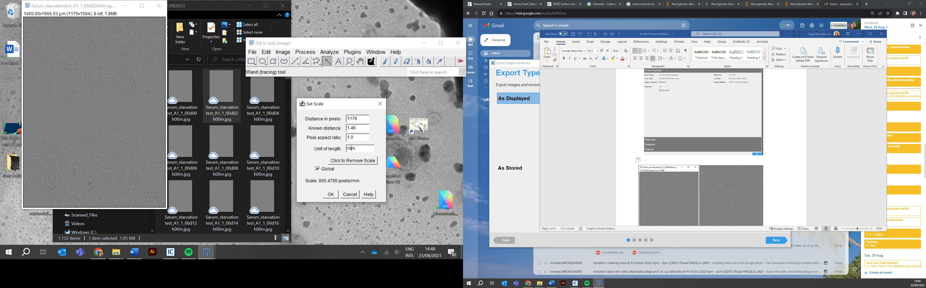

This is because the 8-bit image extracted from the program has this as pixel width which is 1.46 mm of Known distance. See bellow.

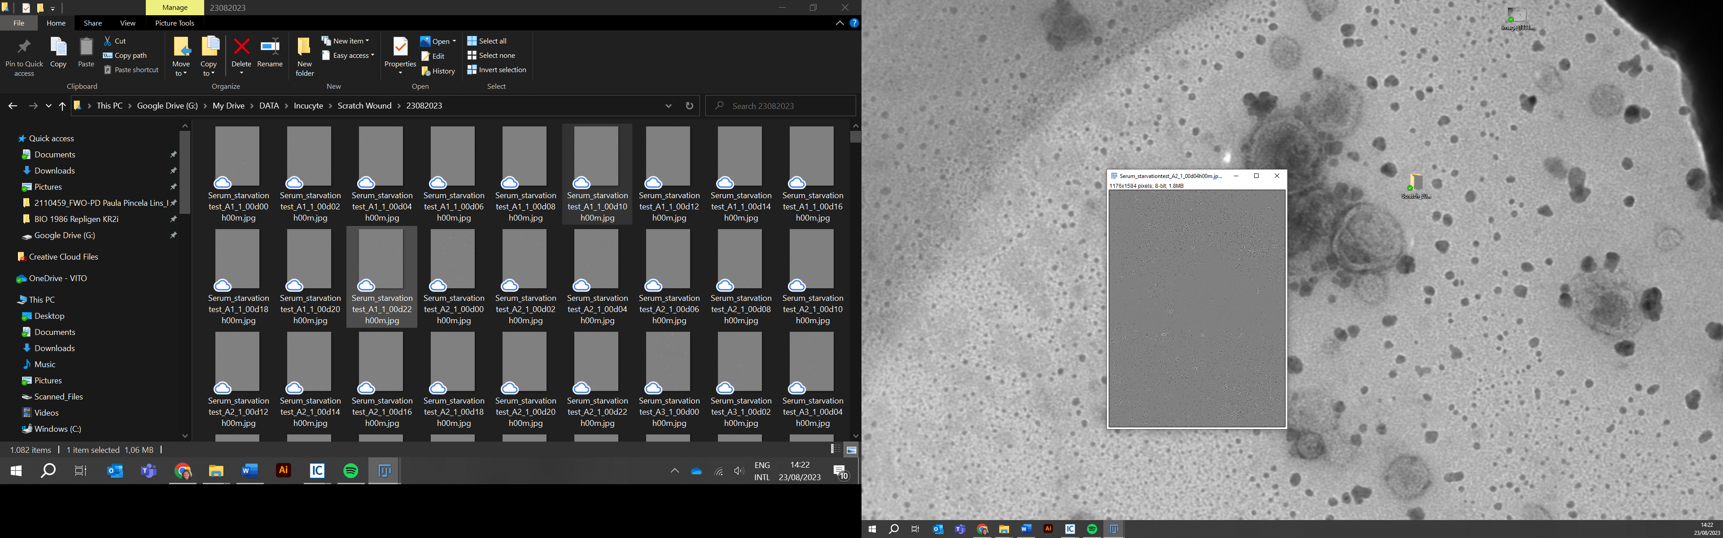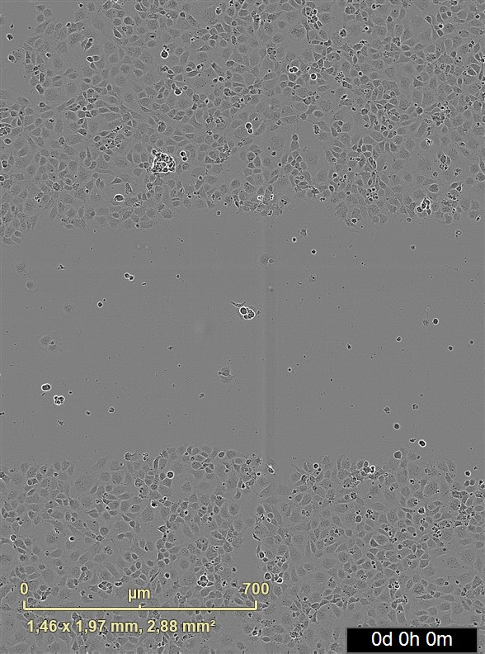

However, if you change the magnification or the size of the extracted image, this needs to be recalculated by following the protocol above.

# **Setting up the macro for Wound Area**

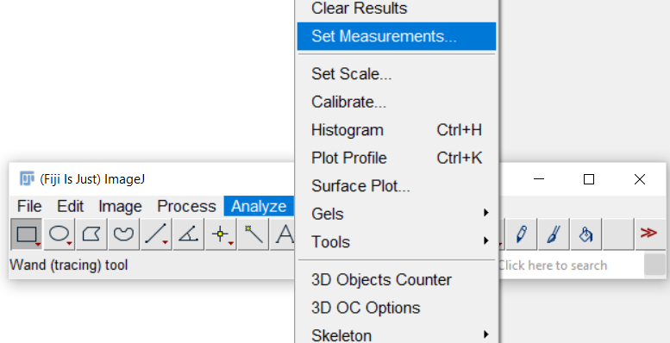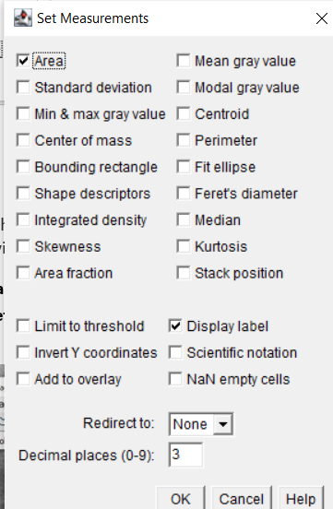

* Open **Analyze > Set measurements**. Make sure Area and Display label are ticked

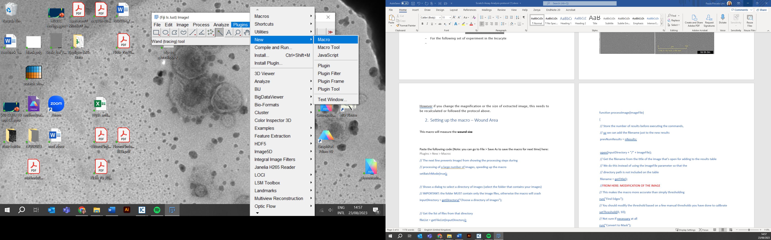

* Select **Plugins> New> Macro**. The Macro window will open

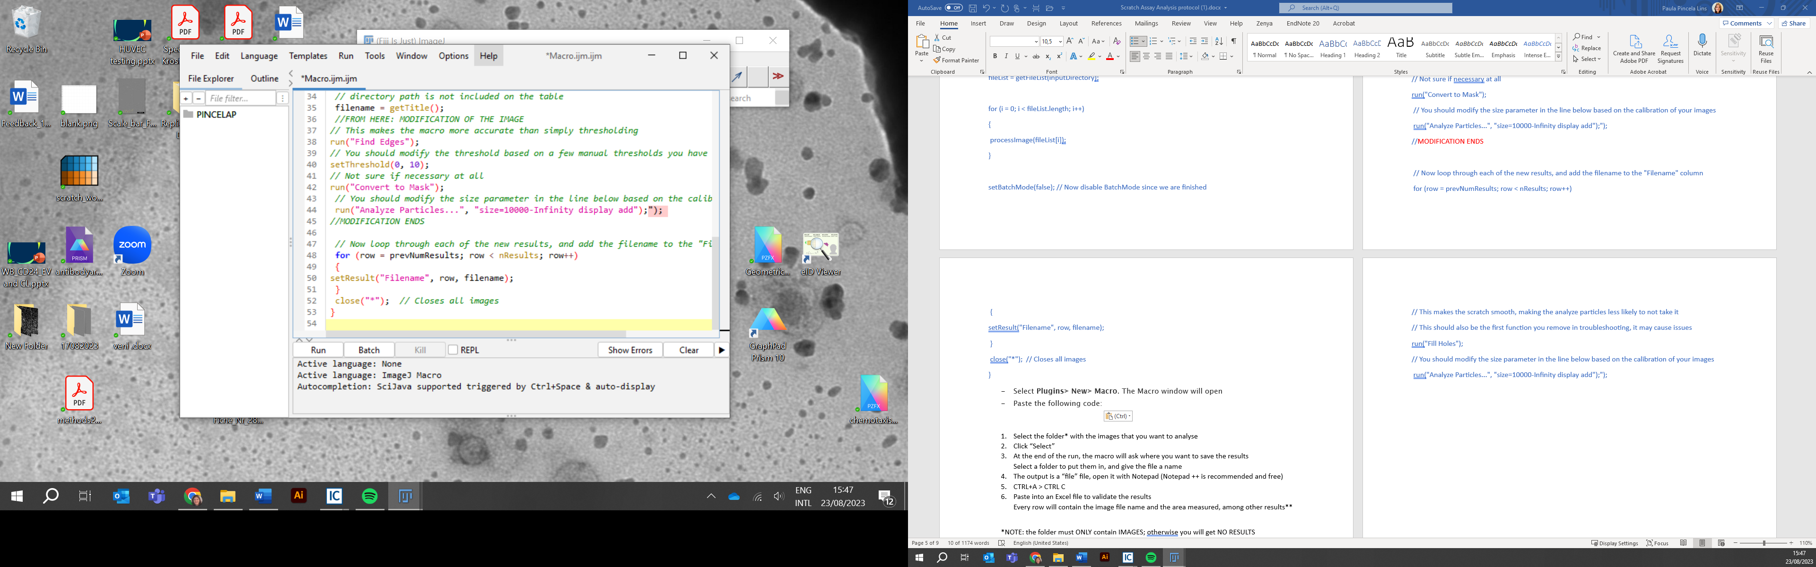

* Paste the following code:
  + Note: you can save this as a .ijm file and open that file from then on

// Ask for input & output folders

inputDir = getDirectory("Choose Input Folder");

outputDir = getDirectory("Choose Results Output Folder");

// Create dialog for user parameters

Dialog.create("Batch analysis parameters")

Dialog.addNumber("Lower Threshold, based on calibration", 0);

Dialog.addNumber("Upper Threshold, based on calibration", 6);

Dialog.addNumber("Min. Particle Size (px^2)", 50000);

Dialog.addNumber("Max. Particle Size (px^2), Infinity for no limit", 1e12);

Dialog.show();

// Get dialog values

lowThr = Dialog.getNumber();

highThr = Dialog.getNumber();

minSize = Dialog.getNumber();

maxSize = Dialog.getNumber();

// File loop

run("Clear Results");

fileList = getFileList(inputDir);

nimages = lengthOf(fileList);

setBatchMode(true);

// A failsafe is added that checks whether the file is an image before opening

for (i = 0; i < nimages; i++) {

fileName = fileList[i];

if (endsWith(fileName, ".tif") || endsWith(fileName, ".jpg") || endsWith(fileName, ".png")) {

fullPath = inputDir + fileName;

open(fullPath);

// Image processing

run("Find Edges");

setThreshold(lowThr, highThr);

run("Convert to Mask");

run("Analyze Particles...", "size="+minSize+"-"+maxSize+" display add");

close();

}

}

// Save results once, after the loop finishes

savePath = outputDir + "results.csv";

saveAs("Results", savePath);

print("Results saved to: " + savePath);

* Select Run (**CTRL+R**)
* A new window will open, and you must select the **folder** with images that will be analyzed
* A second window will open, and you must select the **output folder** for your results to be saved to
* Finally, please input the desired threshold and minimum particle values for the code based on your own calibration
* A window with the results will open. The Area represents the size of the wound.
* Once the processing is done, the file will save to the output folder you selected
* If you would like to use Excel: open in Excel
  + Select the column > Data > Text to columns > Select delimiter (,) > Finish
* Any Images with multiple area measurements will show up multiple times
  + This means that the wound partially closed and there is more than one region of the wound
  + To sum these multiple areas so there is one measurement per file:
    - Select all data (including headers).
    - Go to Insert > PivotTable (or “Recommended PivotTables” in newer Excel versions).
    - When asked, choose “Select a table or range” (your highlighted data) and “New Worksheet” (or “Existing Worksheet”). Click OK.
    - In the PivotTable Fields pane (usually on the right):
    - Drag Filename to the Rows area.
    - Drag Area to the Values area.
    - Excel automatically uses “Sum of Area” as the default (if not, click the drop-down on Area in Values, select Value Field Settings, and choose Sum).
    - You now have a pivot table that shows one row per filename with the sum of all Area measurements for that file.
  + Check following the quality control code below

1. **Optional: Quality Control**

To evaluate the images processed (this will save the processed images with an overlay of the measured area)

* Select **ImageJ > Process > Batch > Macro**

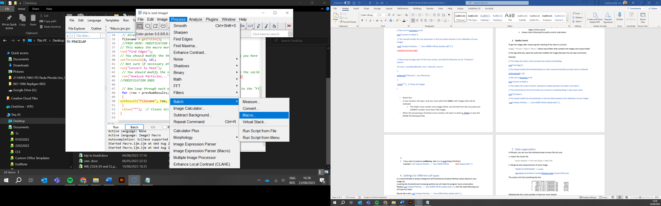

* A New window will appear

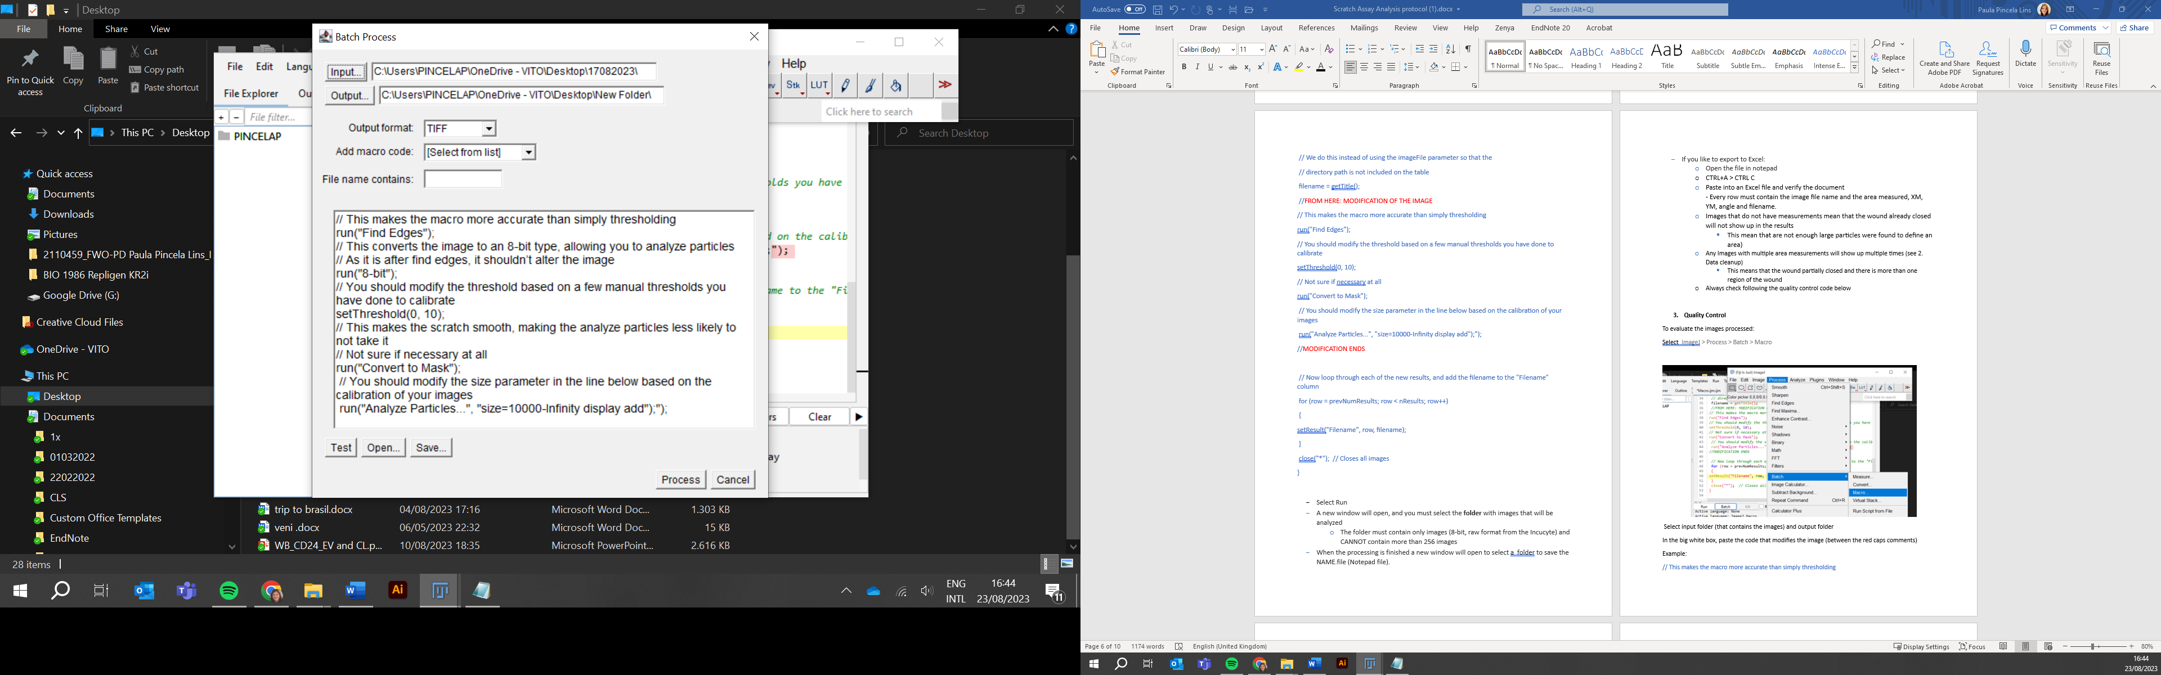

* Choose the folder analyzed before as input folder and the output folder (where the images will be saved)
* Paste the code from the modification of the image images (between the red lines)  
  If you made changes, use the changed modification here

//FROM HERE: MODIFICATION OF THE IMAGE

run("Find Edges");

setThreshold(0, 6);

run("Convert to Mask");

run("Analyze Particles...", "size=50000-Infinity display add");

//MODIFICATION ENDS

* Check the images

# **Settings for different cell types**

* It is recommended always to change the set threshold and Analyze Particles values based on your cell type and image quality.
* To verify which settings define better the wound area, follow the quality control protocol and play with Threshold and Particle size in the following lines:
  + Replace run("Analyze Particles...", "size=10000-Infinity display add");");
  + setThreshold(0, 10);
* Lowering the threshold and increasing particle size will make the program more conservative

Values for some tested cells:

**Neural stem cells (NSCs):**

Change the particle size range:

run("Analyze Particles...", "size=1000-Infinity display add");");

**HUVECs**:

// This makes the macro more accurate than simply thresholding

run("Find Edges");

// You should modify the threshold based on a few manual thresholds you have done to calibrate

setThreshold(0, 10);

// Not sure if necessary at all

run("Convert to Mask");

// This makes the scratch smooth, making the analyze particles less likely to not take it

run("Fill Holes");

// You should modify the size parameter in the line below based on the calibration of your images

run("Analyze Particles...", "size=1000-Infinity display add");");

# **Optional: Data organization in RStudio**

In RStudio, you can sum the individual areas of every file into one:

1. Import the results file

Import dataset > From text (base) > Select file

2. Merge all area measurements of every image

“NAME OF DATAFRAME” -> results

aggregate(results$Area~results$Filename,data=results,FUN=sum)

The output will look something like this:

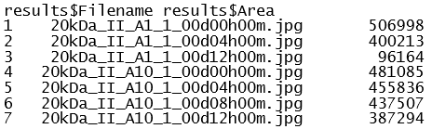

(Merging like this is also possible in Excel, see earlier)

To split the filename column,use the dplyr function separate()

# **Troubleshooting**

1. Check that the folder only contains images
2. Split the folder into two smaller folders (If macro crashes in the middle of working due to “file not open” error)